NEXTAG

## 

## 

| Supervisor | Miss Fariha Shafiq | |
| --- | --- | --- |
| Batch. | 2410F1 | |
| Group. | A | |
| Serial No. | Enrollment No | Name |
| 1 | 1610219 | Ahmad Ur Rehamn |
| 2 | 1610500 | Farooq Daniyal |
| 3 | 1613926 | M. Arman |
| 4 | 1612275 | Abdullah Sardar |

## 

# 

# Overview

NEXTAG is a premium online store specializing in **high-quality handbags, wallets, backpacks, and accessories** from top brands. Designed for both men and women, NEXTAG offers a **curated selection of luxury and everyday bags** to suit various styles and needs.

With a focus on **exceptional craftsmanship, durability, and elegance**, NEXTAG provides **detailed product insights, comparisons, and an easy shopping experience**. Customers can browse collections, compare features, and make informed purchases with confidence.

In addition to retail, NEXTAG also offers **professional handbag repair, cleaning, and restoration services**, ensuring that beloved accessories maintain their **beauty and longevity**.

Whether you're searching for a **classic leather purse, a stylish travel bag, or a functional wallet**, NEXTAG delivers **premium quality and timeless designs** in one convenient platform.

.

# Problem Definition

With the increasing demand for **luxury handbags and accessories**, customers seek a **seamless shopping experience** where they can explore **genuine branded products, compare features, and receive repair services**. NEXTAG aims to bridge the gap by providing a **well-structured, user-friendly, and visually appealing platform** for its customers.

## **Customer Requirement Specification (CRS)**

## The Web site is to be created based on the following requirements.

1) The Home Page should be created with proper sections and with a suitable

logo.

2) Home Page should contain details on Purse and Wallets with suitable images.

3) The site should display a menu which will contain the options for brief

introduction about the various purse and wallets available, location of the

shop and any other information if required.

4) The information should be categorized according to the brand names of the

products like if a User wants to see only “LOUIS VUITTON” products or any

other companies products then he/she can click on a Link/button/menu etc

and can see only that Brand products.

5) When a user selects any particular brand, a list of products for that brand will

be displayed

6) A brief summary of features of individual products should be displayed on the

Web Page along with the product but detailed Features should be stored in

Individual Word documents which can be downloaded or viewed by the User

who wishes to see the same.

7) The user should also be able to compare the various products of different as

well as similar brands.

8) There should be a “Contact Us” page which will have the Address of the

Company which is as follows and the mail address which when clicked will

invoke the local mail client from where they can send an email.

## **Scope of Work**

The website is to be developed for the Windows Platform using HTML5,

JavaScript and bootstrap jQuery. The site should work well in all leading

browsers including Chrome, Firefox etc. Our welcome page icon is re-directed

to the main web page Ever essential content direct to relative content.

## **Aggregated Sitemap**

**Main Pages:**

* Home
* About Us
* Products
  + Handbags
  + Wallets
  + Backpacks
  + Accessories
* Product Comparison
* Services
* Contact Us
* Check-out

## **Work Done By Group Members:**

Ahmad Rehman:

Home Page : design, content and code

Blog Page: Design, Content and Code

Services Page: Design,Content and Code

Contact Page: Design, Content and Code

Overall webpage design: Whole team

Farooq Daniyal:

Shop page for men: Content and Code

Shop page for women: Content and Code

Arman:

About Page: Design, Content and Code

Word files for user for more info about product

Abdullah:

Content searching

**Screen Shots**

Home page:

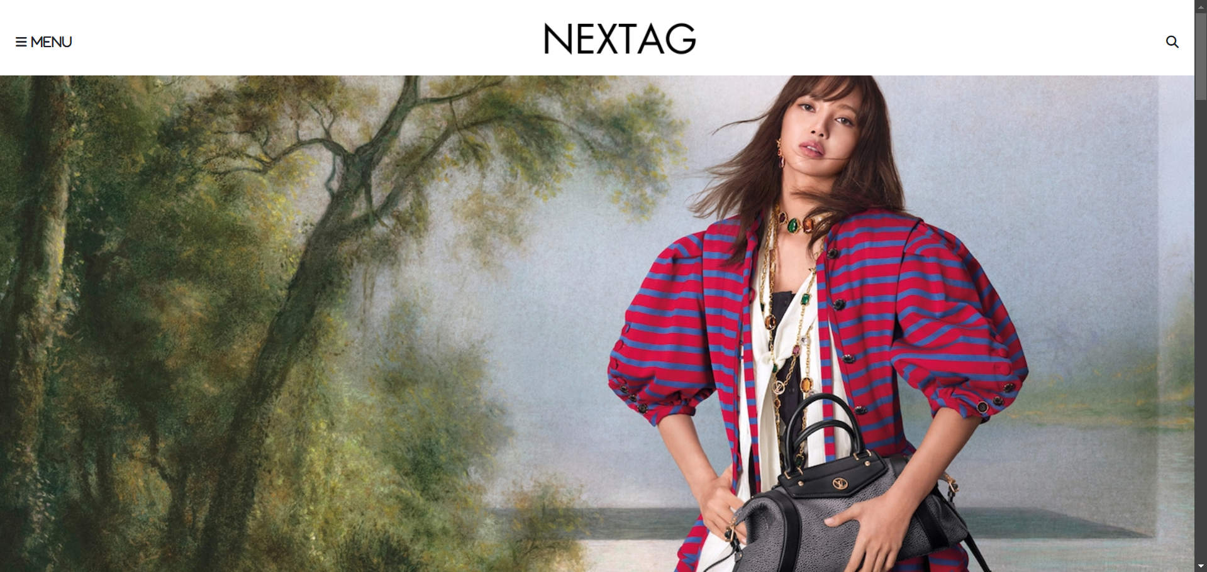

Contact page:  
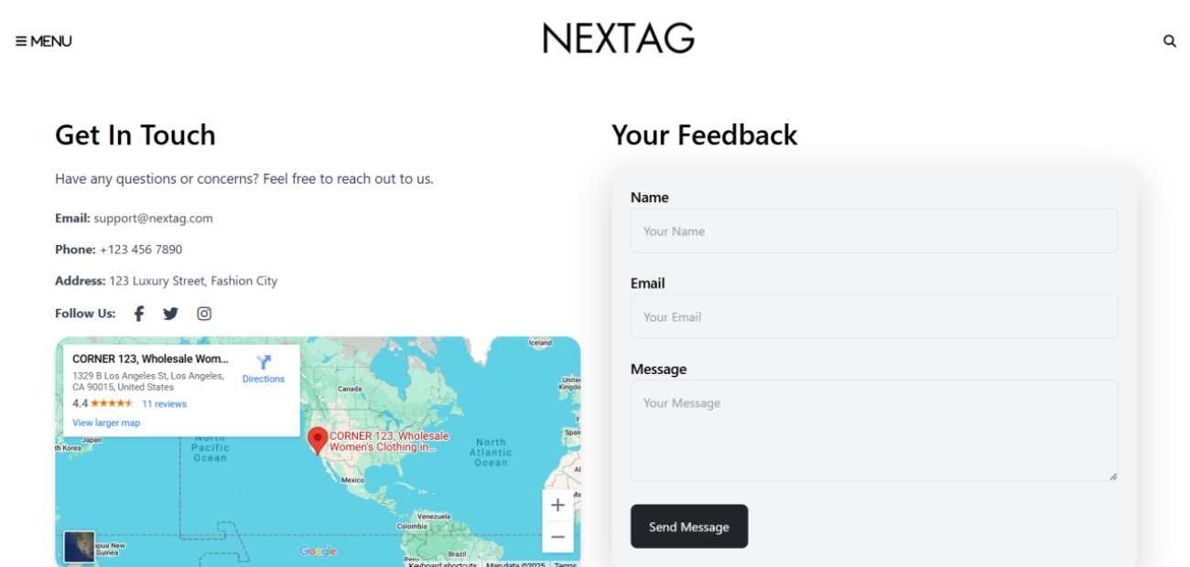

ABOUT PAGE:  
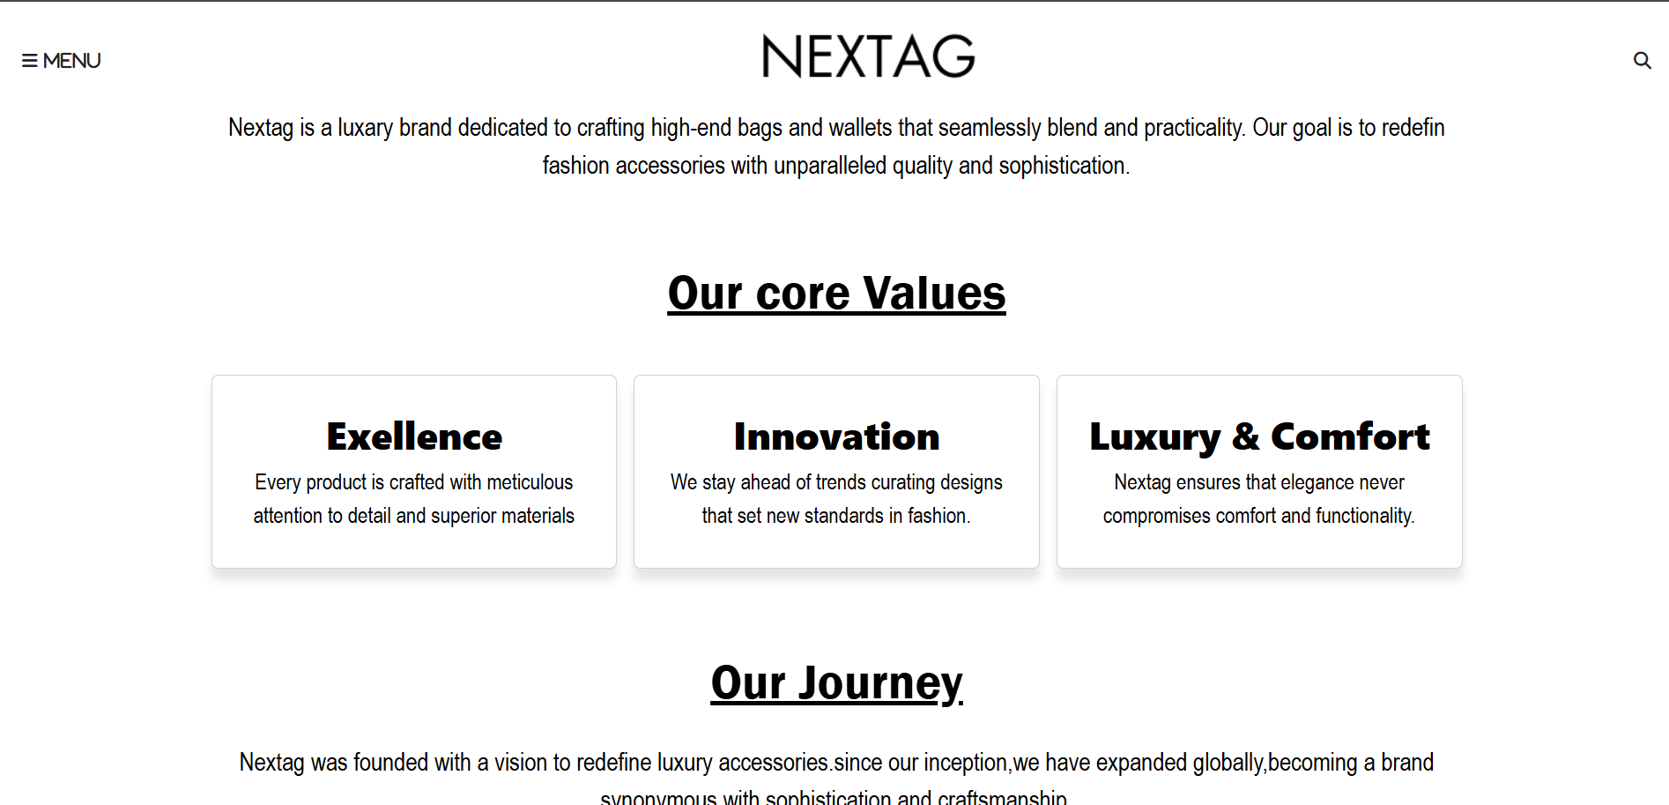

CHECK OUT PAGE  
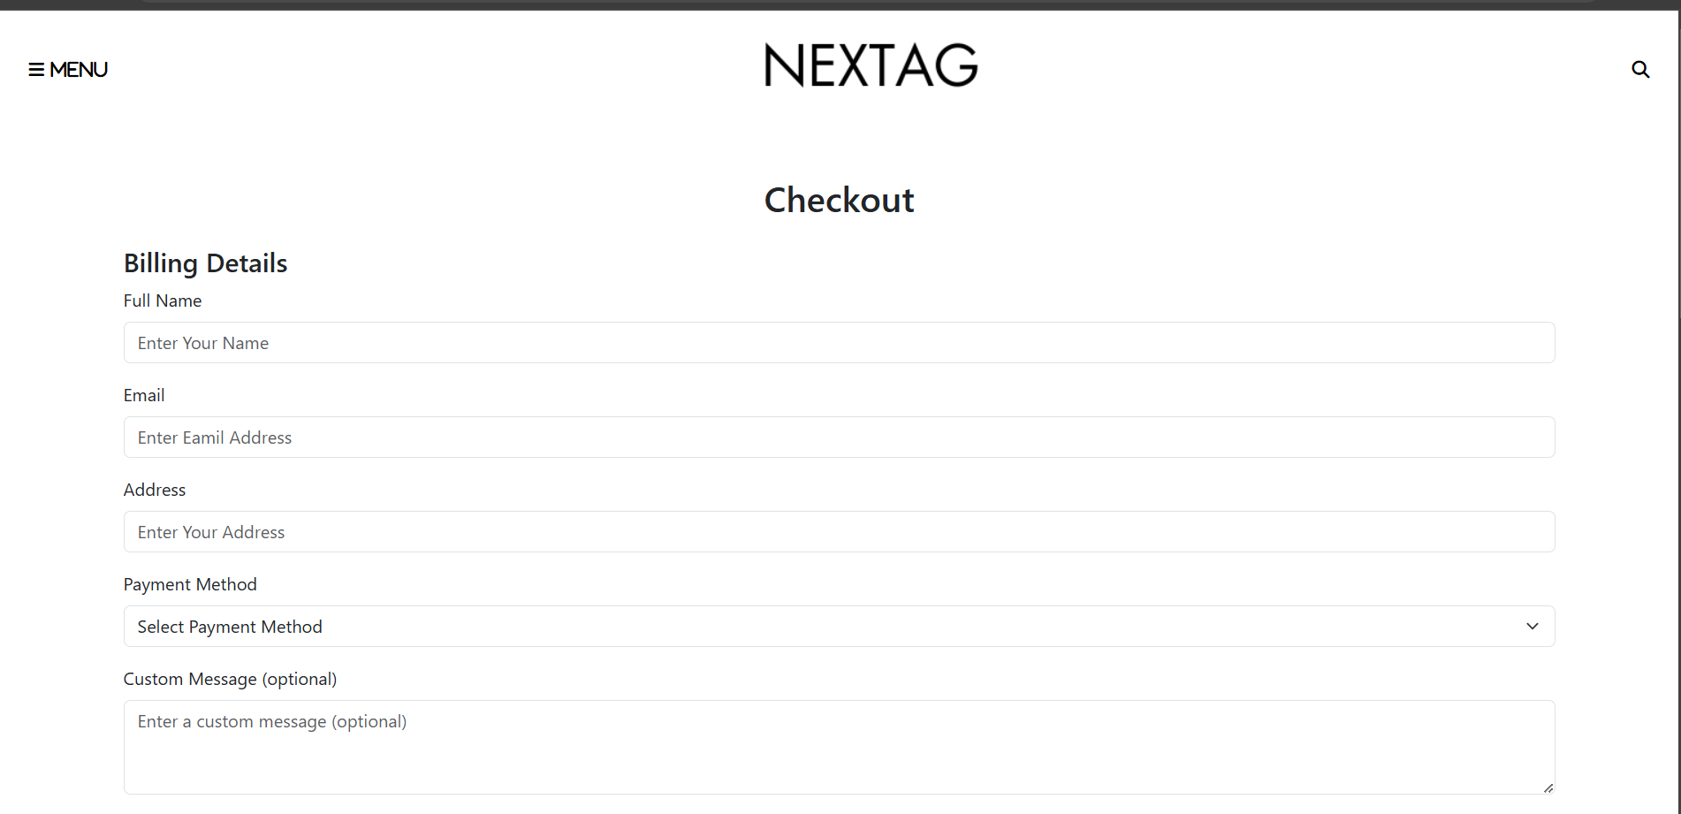SERVICES PAGE: 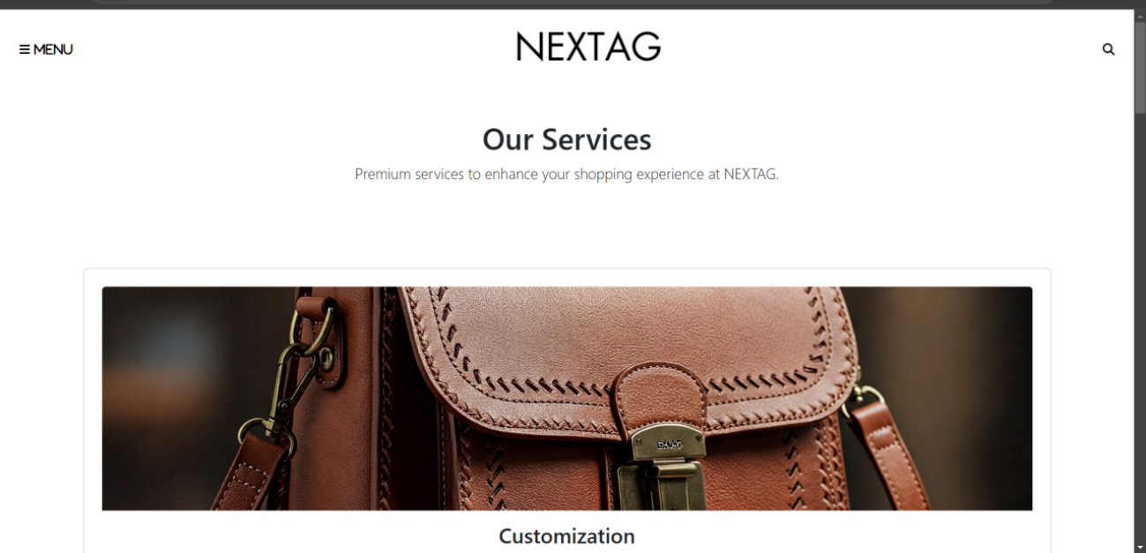

BLOG PAGE:

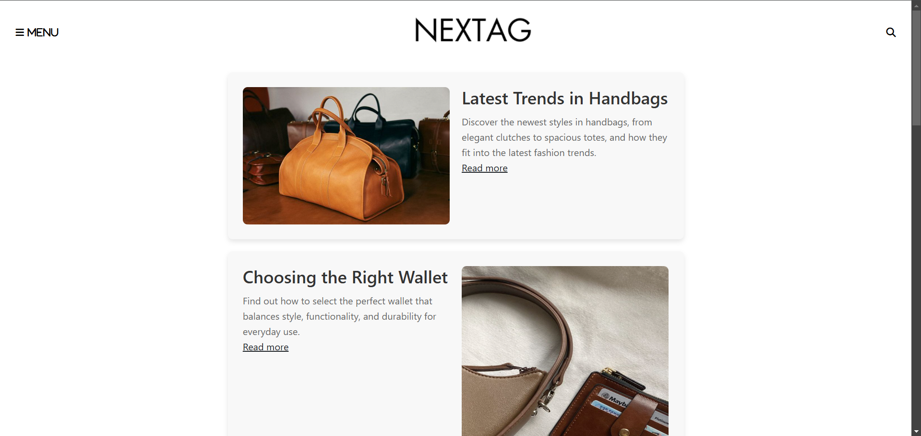

NEW ARRIVAL PAGE:

